Johnson Le

Lab 3 Prelab

**Part 1:**

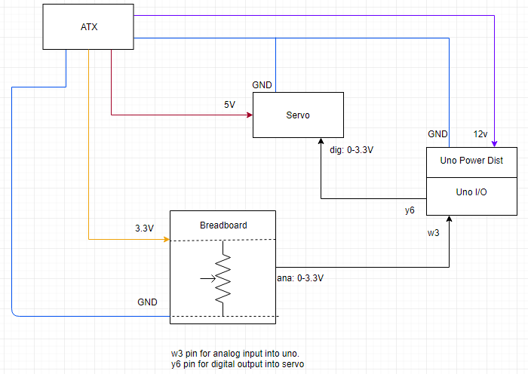RC_Init();

RC_AddPins(RC_PORTY06);

BOARD.Init();

AD.Init();

LED.Init();

**Part 2:**

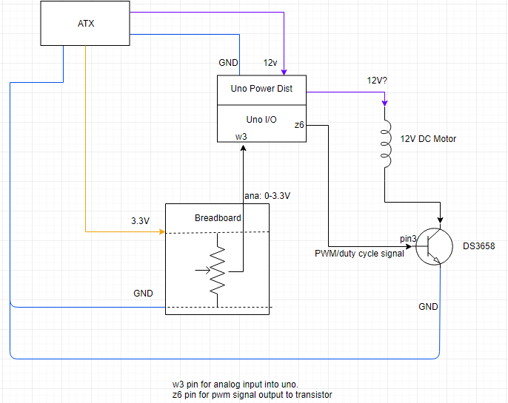

BOARD.Init();

AD.Init();

PWM_Init();

PWM_AddPins(PWM_PORTZ06);

PWM_SetDutyCycle(1, “amnt based on potentiometer”);

LED.Init();

**Part 3:**

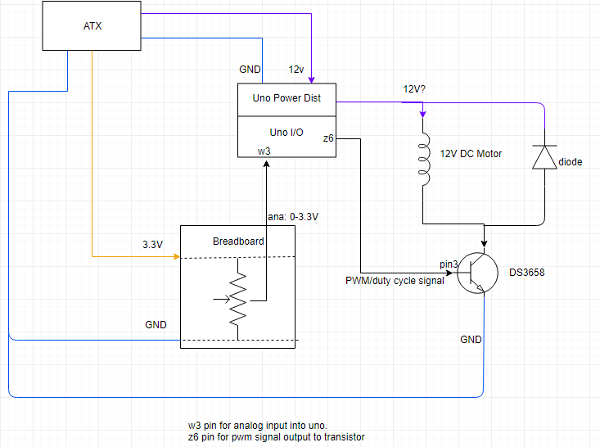

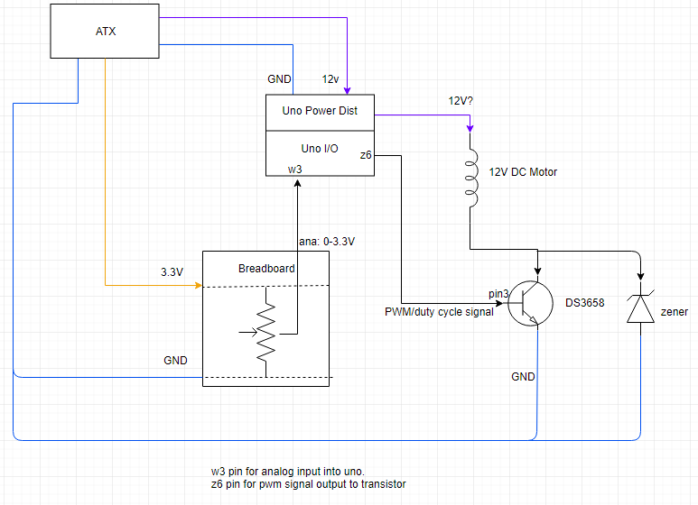

LED.Init();

BOARD.Init();

AD.Init();

PWM_Init();

PWM_AddPins(PWM_PORTZ06);

PWM_SetDutyCycle(1, “amnt based on potentiometer”);

**Part 4:**

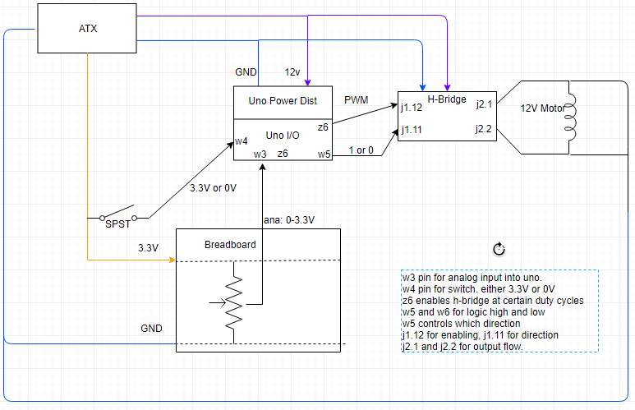

BOARD.Init();

AD.Init();

LED.Init();

PWM_Init();

PWM_AddPins(PWM_PORTZ06);

PWM_SetDutyCycle(1, “amnt based on potentiometer”);

**Part 5:**

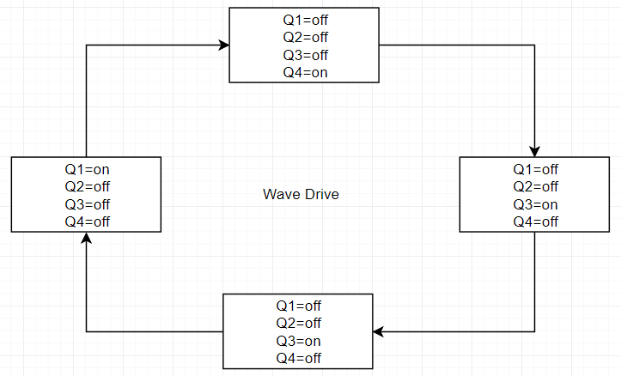

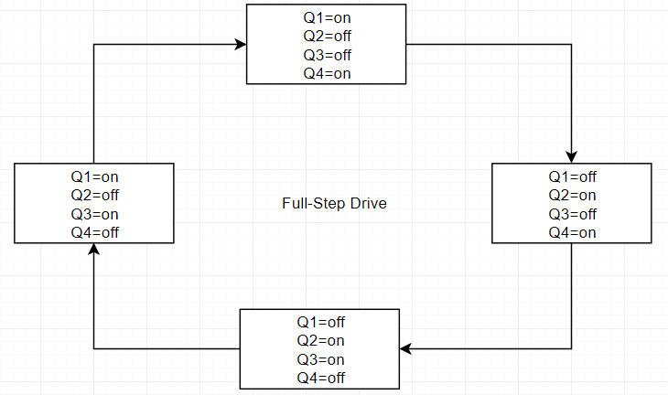

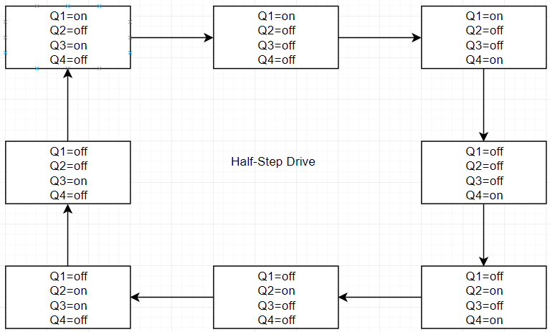

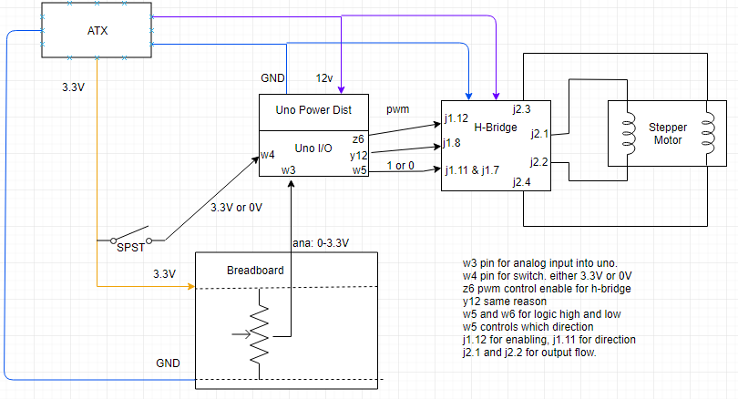

BOARD.Init();

LED.Init();

AD.Init();

PWM_Init();

PWM_AddPins(PWM_PORTZ06);

PWM_SetDutyCycle(1, “amnt based on potentiometer”);

**Part 6:**

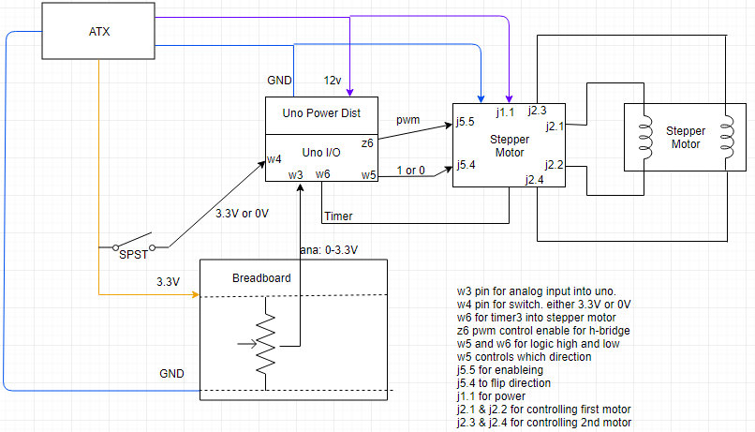

BOARD.Init();

AD.Init();

PWM_Init();

PWM_AddPins(PWM_PORTZ06);

PWM_SetDutyCycle(1, “amnt based on potentiometer”);

